Mockito Hands-On Exercises
Exercise 2: Verifying Interactions
VerifyInteractionTest.java:
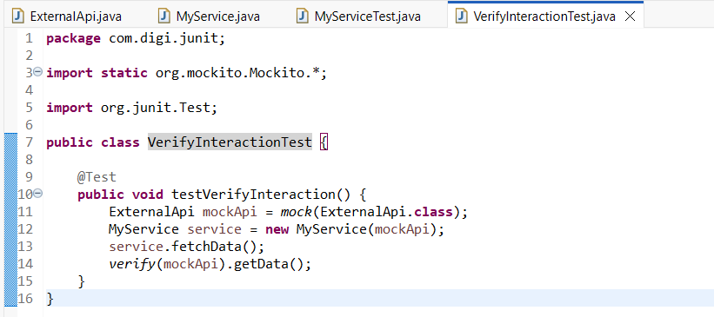

Output:
